John Michael Go
Career Entry Level Java Programming
Date: Jan. 18, 2013

DAY 6

Program Name: TempConversion

Objective: Program that computes for the Fahrenheit value of the Celsius input.

Algorithm:

1. User inputs value in Celsius.
2. Program will display the equivalent value in Fahrenheit.

Flowchart:

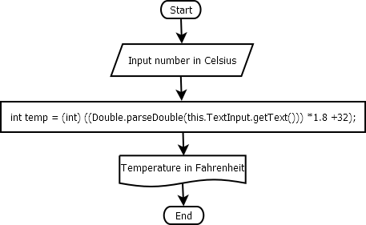

Pseudocode:

private void ComputeActionPerformed(java.awt.event.ActionEvent evt) {
int temp = (int) ((Double.parseDouble(this.TextInput.getText())) *1.8 +32);
TextInput2.setText(temp +" ");
}

Screenshot:
